Diameter sensor selection

Owen Lu

Electroimpact Inc.

owenl@electroimpact.com

*Abstract*—This document details the tests that were conducted on 3 different distance sensors that will be used for spool diameter sensing and inertia estimation on new AFP heads systems.

# Introduction

The reason tests are conducted is to evaluate the performance of the different sensors in terms of precision and accuracy in a realistic setting. Practical implementation issues, such as wiring difficulty will also be taken into account in the end qualitatively, although evaluation of this is not covered in this specific document.

# Sensors

Of the three sensors, two are laser sensors, while one is an ultrasonic sensor. The family part numbers are listed below with hyperlinks:

1. [Balluff BOD000N](http://www.alliedelec.com/balluff-bod000n/70376789/) (Laser)
2. [Leuze ODSL8](http://www.leuze.com/en/deutschland/produkte/messende_sensoren/abstandssensoren/optische_abstandssensoren/odsl_8/selector.php?supplier_aid=50108362&grp_id=A1-2-1-1-1&lang=eng) (Laser)
3. [Balluff S004J](http://asset.balluff.com/std.lang.all/pdf/datasheet/0_/gl/Datasheet_BUS004J_223120_GL.pdf) (Ultrasonic)

# Apparatus

Since servo spool research is being conducted simultaneously, the same test rig was used, a solid model representation is shown in Figure 1.

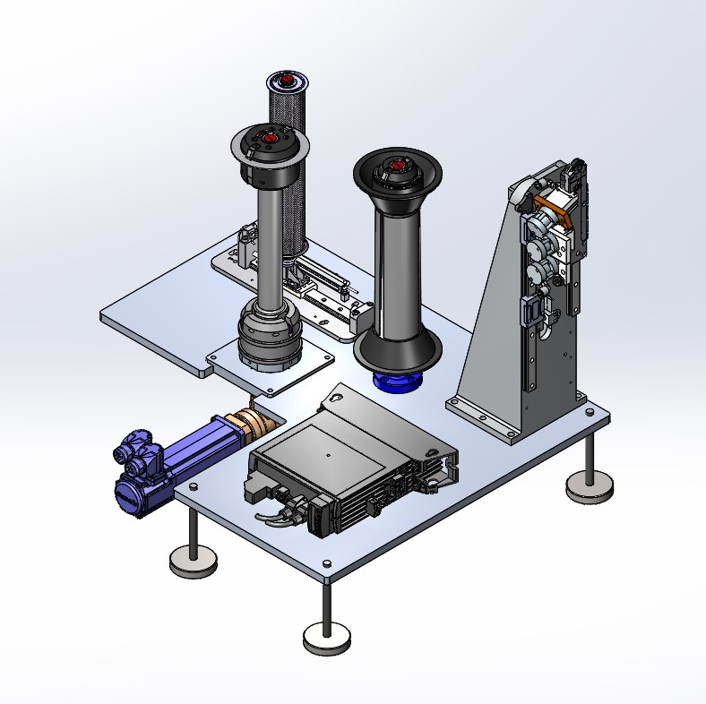

Figure 1- Solid model representation of test apparatus

The reason it is mounted to the test rig is so that the servo can rotate and the angular position of the output shaft can be recorded simultaneously with the diameter measurements.

# Procedure

The experimental procedure is listed below.

1. Connect sensor to Bosch IndraDrive
2. Mount spool of known diameter (measured via calipers)
3. Record input voltage
4. Mount second spool of known diameter (measured via calipers)
5. Record input voltage
6. Perform linear calibration for interpolation and extrapolation for diameter
7. Use Bosch IndraWorks oscilloscope function to record data (time, angular velocity, diameter reading)
8. Run step velocity input of 80RPM
9. Stop recording
10. Repeat 7-9 with 120, 160, and 200RPM
11. Repeat 1-10 with all sensors

# Performance metrics

The main metric in quantifying reliability taken into consideration as the maximum and minimum deviation in the time domain signal as recommended by Chris Connair.

Although each measurement is important, more importantly is the average of the measurements over one revolution. Of course the angular rate combined with the sampling rate $T_{s}$ defines how many measurements can be taken over one revolution.

To calculate the number of samples $n$ we can use Eq. (1) and (2).

|  |  |  |
| --- | --- | --- |
|  | $$T=\frac{2π}{ω}$$ | (1) |
|  | $$n=\max\left\{n∈Z,n<\frac{T}{T_{s}}\right\}$$ | (2) |

The standard error of the measurement can be estimated with

|  |  |  |
| --- | --- | --- |
|  | $$SE_{\overline{x}}=\frac{s}{\sqrt{n}}$$ | (3) |

During the fastest payout of 1.69m/s with the smallest spool diameter of 3.5’’ allows us to calculate the minimum theoretical $n$ value based on given $T_{s}$.

$$ω=38rad/s$$

$$T=\frac{2π}{ω}=0.1653s$$

Therefore, 1000Hz sampling rate, would mean $n=165$. An example calculation follows of how to estimate the 95% confidence interval of the mean value.

For the Balluff laser sensor, the standard deviation was measurement to be $s=5.86mm$. This was by far the worst performing sensor of the three, and gives an upper bound of the expected standard error.

Therefore, $SE_{\overline{x}}$ can be calculated and the 95% confidence interval estimated.

$$SE_{\overline{x}}=\frac{5.86mm}{\sqrt{165}}=0.4562mm$$

$$95\% CI≈\left(\overline{x}-2SE_{\overline{x}},\overline{x}+2SE_{\overline{x}}\right)$$

This means that with 95% confidence, the diameter of the spool can be estimated to within ~1mm assuming zero offset error. Knowing that this can estimate the magnitude of random error, it shows that all sensors are sufficient for the job.

Tabulated below are the results for the maximum and minimum along with the 95% confidence interval. The measured diameter using calipers was 95.4mm.

|  |  |  |
| --- | --- | --- |
| Sensor | 95% CI (mm) | Min/Max (mm) |
| BOD000N | (94.4, 96.3) | (79.7, 105.0) |
| ODSL8 | (95.0, 95.7) | ( 87.4, 99.2) |
| S004J | (95.2, 95.52) | (93.9, 96.5) |

All sensors agree with the caliper measurements within their 95% confidence intervals and are suitable for the task. However, a construction of polar plots given time domain angular position and radius measurements allows us to see the clear winner instantly. Following are the polar constructions of the time domain diameter data in Figure 2.

|  |
| --- |
| C:\Users\owenl\Documents\2TOW\TESTS\SPOOL_ULTRA.bmp |
| C:\Users\owenl\Documents\2TOW\TESTS\SPOOL_LASER_2.bmp |
| C:\Users\owenl\Documents\2TOW\TESTS\SPOOL_LASER.bmp |

Figure 2 - Polar construction of spool; Ultrasonic (top), Leuze laser (middle), Balluff laser (bottom)